| **Date:**  05/10/2022 | **Assessed by:**  John Bramwell | **Approved by:**  Kamal Qazi | **Building / Location:**  Makerspace GA.041 | **Assessment ref no:** | **Expiry date:**  September 2023 |
| --- | --- | --- | --- | --- | --- |
| **Task/Premises:**  University of Manchester students working on individual projects or part of a team within Makerspace. Each project activity must have its own Risk Assessment, This RA documents known hazards within the area. Students working on projects in makerspace have access to all the tools available however this is dependent on supervisor approval, correct training and supervision. | | | | | |
| **Please add as appropriate once known:**   |  |  |  |  |  |  | | --- | --- | --- | --- | --- | --- | | **LABORATORY HAZARDS** | | | | | | |  |  |  |  |  | insert hazard symbol here | | **CONTROL MEASURES** | | | | | | |  | C:\Users\f58531as\AppData\Local\Microsoft\Windows\INetCache\Content.MSO\8CE47D0F.tmp | C:\Users\f58531as\AppData\Local\Microsoft\Windows\INetCache\Content.MSO\F7DF0DA3.tmp | C:\Users\f58531as\AppData\Local\Microsoft\Windows\INetCache\Content.MSO\4C4B9F4F.tmp | C:\Users\f58531as\AppData\Local\Microsoft\Windows\INetCache\Content.MSO\BD952CBF.tmp | C:\Users\f58531as\AppData\Local\Microsoft\Windows\INetCache\Content.MSO\B6709425.tmp | | | | | | |

| **Activity** | **Hazard** | **Who might be harmed and how** | **Existing measures to control risk** | **Risk rating** | **Result** |
| --- | --- | --- | --- | --- | --- |
| Fire prevention and protection  **E=essential** | Fire  Smoke | Staff and students, visitors.  If present within the building during fire  Death  Burns  Smoke inhalation | * Induction arrangements cover security and fire awareness and include how to locate and use a fire door to exit the building and the location of the fire assembly point(s). * All new staff complete fire awareness e-training. * Fire alarm system are in place and tested weekly on day at time to enable users to identify the sound of the alarm   + 09:30 – Oddfellows Hall   + 09:45 – Engineering Building A   + 10:00 – Engineering Building B   + 10:15 – York Street Building   + 10:30 – North Basement   + 10:45 – South Basement   + 11:00 – Active Travel Hub * Fire evacuation practices are carried out annually * Induction covers the importance of maintaining clear fire exit routes and keeping the doors closed unless essential. Induction also covers the need for high general housekeeping standards. * Monthly self-inspections must highlight any fire risks. * Ready access to fire extinguishers is available for use by trained users. * Staff ‘hosts’ responsible for safety and, if required, evacuation of visitors. * Evacuation marshals attend suitable training and assist where possible during evacuations during normal working hours. * Requests to work out of hours include emergency action in case of fire and use of fire routes and doors. * The section on chemical storage must also be considered in a DSEAR assessment. | LOW | A |
| Action in the event of an emergency  **E=essential** | Not being aware of the evacuation procedure in the event of an emergency.  Injuries/chemical contamination  Lack of assistance out of hours | Staff, students and visitors.  Lack of awareness  /unacceptable behaviours when the fire alarm sounds may result in assuming that real alarms are practice drill and subsequently delay evacuation leading to being trapped by fire or other life threatening incident.  Individuals may not find the first aid kit, emergency showers, fire exits | * Users are instructed and empowered to act if they suspect an emergency situation to activate the fire alarm to trigger evacuation of the building. * All incidents are reported as required to the person responsible for the area and to a School Safety Advisor * First aid notices are situated in prominent places around the building to be consulted when first aid is required for appropriate response   + For life-threatening emergencies: Call emergency services on 999, then inform Campus Security.   + For serious injuries and illnesses (and out of hours first aid): Call Campus Security on 0161 306 9966.   + For minor injuries and illnesses 9am-5pm: Locate first aider using QR code located on the First aid notice * First aid provisions within the area are checked as part of monthly self-inspections in high risk areas. * Actions to take in the event of chemical spills/gas leaks are known to those concerned see relevant sections below and may require use of an Emergency Response Team * How to contact Security if required using the telephone number on the back of UoM ID cards (0161 3069966) is emphasised at induction | LOW | A |
| Students Working in makerspace  **E=essential** | Lack of knowledge and experience  Lack of competence and/or training  Inadequate risk assessment of work and/or situations | The individual and others in the vicinity and building  Lack of competence and/or training  Inappropriate action or lack of action could lead to incidents and injuries which supervision and training could have avoided | * Induction, including identified specific equipment and technique training must be provided by academic supervisor, technical staff or competent delegate. * Training and competency must follow guidance set out in by the Faculty * Workspace users to be made aware of Department Health and Safety Policy, the contents of it and where it is located during workspace inductions | LOW | A |
| Students in makerspace  **E=essential** | Thermal comfort  Extremes of heat and cold effect ability to work/concentrate/manipulate experiments | Staff, students and visitors.  Failure of the system can result in uncomfortable temperatures | * Staff/students must report any failings or concerns to Estates (Helpdesk) by calling 52424 or using the on-line reporting form. * Staff/students should also report to their manager/PI. * Fan heaters or air conditioning units are not to be brought into the space unless facilitated by Estates. | LOW | A |
| Students in maker space  **E=essential** | General Ventilation  Equipment failure  Insufficient ventilation either natural or forced | Staff, students and visitors.  Lethargy  Discomfort  Lack of ventilation decreases the supply of fresh air and could affect temperature and/or odour within the area leading to adverse health effects | * High-risk areas are subject to regular air changes. * Provision is managed and maintained by the Estates function. * Faults are reported to the Estates helpdesk by area users. * If it is suspected that ventilation/make-up air is not functioning correctly, the contact number for estates is x52424 from an internal phone or 0161-2752424 from an outside line /mobile. | LOW | A |
| Students in makerspace  **E=essential** | Inadequate lighting | Staff and students, Visitors.  Eye strain  Trips/falls/slips  Impact injuries  May walk into something or something may fall onto individual as they reach for an item | * Lighting levels are maintained as the building was designed and Estates maintain the infrastructure and change/fix the lighting on request. Report any concerns to Estates (Helpdesk) by calling 52424 or using the on-line reporting form * Windows are provided for natural lighting. * Good housekeeping is in place to minimise items that individuals may trip over if lighting is low. | LOW | A |
| Students in makerspace  **E=essential** | Poor housekeeping | Staff and students, Visitors.  Stress from not being able to locate items.  Tripping up on unexpected items.  Cuts/falls/bruises/sprains/strains from slipping on items left on the floor or surfaces.  Items can act as fuel for fire. | * Reasonable standards of housekeeping are regularly maintained, and checks recorded on a monthly basis by users. * Staff and students agree during induction to read and abide by the Department’s health and safety policy which states the guidelines for housekeeping. * Refer to activity “fire”. | LOW | A |
| Students in makerspace  **E=essential** | Lack of space  Safe access and egress | Staff and students, Visitors.  Bruises, sprains and strains - lack of space can lead to injuries through collisions with furniture, equipment or other persons.  Egress is restricted or prohibited by items stored incorrectly. | * Use of appropriate sized furniture. * Reasonable standards of housekeeping are maintained and checked on a monthly basis by users. Staff and students agree during induction to read and comply with the Department’s health and safety policy which states the guidelines for housekeeping. * Space is kept between equipment to enable safe entry and exit, minimum 1.5m * For rooms with single entry/exit point flammable materials are stored as far away from the entry/exit point as possible to maximise the maintenance of safe exit routes in the event of a fire/incident. | LOW | A |
| Students in makerspace  **E=essential** | Poor Hygiene | Staff and students, Visitors.  Discomfort  Inadequate cleaning, water burn, no towels can lead to dermatitis | * Water temperature at hand wash sink can be adjusted and is limited at source. * Soap and paper towels are provided and maintained by area staff or users | LOW | A |
| Students in makerspace  **E=essential** | Waste management/ disposal | Staff and students, visitors.  Discomfort from poor housekeeping and odours | * A variety of waste bins/streams are supplied for recycling and disposal needs. These are covered in local Induction. * House services staff dispose of general waste regularly and as requested by area staff or technical teams. | LOW | A |
| Students in makerspace  Sitting or standing  **E=essential** | Lack of or inappropriate seating | Staff, students, visitors.  Aches and pains from sitting down (tired legs, injuries/illnesses) and seating is not available. | * Suitable seating is provided in all areas as required. * Ergonomic hazards are dealt with separately. | LOW | A |
| Students working in makerspace **E=essential** | Use of mobile phones/devices  Earplugs and earphones | Staff, students, visitors.  Lack of awareness within surroundings leading to vulnerability.  Unable to hear instructions  Unable to hear fire alarms  Distraction from work activities  Chemical contamination of phone/device. | * The use of mobile phones/devices is allowed within makerspace to use for researching/looking up information in relation to work being carried out or accessing appropriate work-based applications. * The use of earplugs and earphones is *discouraged but allowed* within this area. * All those wearing earplugs and headphones must have the sound level where they can still be aware of the people and activities around them to respond in an emergency. * Care must be taken to ensure cross contamination does not occur. | LOW | A |
| Working in high-risk areas  **E=essential** | Ingestion of substances leading to ill-health | Staff, students, visitors.  Eating and drinking I the work area leading to ross contamination or ingestion of hazardous substances  Contamination of equipment with food and/liquids may lead to malfunction | * Eating is prohibited within makerspace. * Suitable rest facilities away from the work area are provided. * Water drinking bottles with a secure top are allowed. | LOW | A |
| Students Traversing around makerspace  **E=essential** | Uneven or damaged flooring | Staff, students and visitors.  Chemical burns  Impact injuries  Sprains and Strains  Inappropriate footwear can catch in flooring that changes level or is in dis-repair, causing trips, slips and falls. | * During induction, individuals are advised of the requirement to wear flat, closed toe, wipe-clean shoes. * Regular checks of the area by users, PIs, managers and Safety Office monitor this. * Staff/students must report any failings or concerns to Estates (Helpdesk) by calling 52424 or using the on-line reporting form. * Care should be taken in high risk areas at all times to help prevent injuries or incidents. | LOW | A |
| Students Traversing around makerspace  **E=essential** | Obstructions and/or spillages | Staff, students and visitors.  Slips, trips and falls  Bruises  Sprains  Strains  Fractures | * Reasonable standards of housekeeping are maintained and checked on a monthly basis by users. Staff and students agree during induction to read and abide by the Department’s health and safety policy which states the guidelines for housekeeping. * Trailing cables must be positioned neatly away from walkways or highlighted with hazard tape. * Faults, repairs and maintenance are reported immediately to Estates (Helpdesk) for repair/replacement * Floors kept clean, dry and clear of obstructions particularly exit routes. Spillages to be cleared immediately – spill kits are available. * Cabinet drawers and doors are kept closed when not in use * Waste bins are supplied for general and recyclable waste reducing the build-up of rubbish in corridors and spaces. * Marked pathways are followed. * Adequate lighting is based on identified activities/tasks in the areas as deemed sufficient during building design specification. Emergency lighting will turn on if standard lighting system is faulty to ensure there will always be light in the areas. * Signage is posted on the doors informing all users of emergency protocols and the telephone number for Security and first aiders if medical help is needed | LOW | A |
| Use of display screen equipment  Repetitive/prolonged use of equipment or tasks  **E=essential** | Incorrect posture whilst using DSE  Incorrect workstation set up  Prolonged use without breaks  Electrical hazards | Staff and students.  Musculoskeletal injuries/disabilities  Limb disorders  Eye strain  Headaches  Back pain  Repetitive strain  Fatigue  Electric shock | * Please refer to the DSE [policy](http://documents.manchester.ac.uk/display.aspx?DocID=24480), guidance and [poster](http://documents.manchester.ac.uk/display.aspx?DocID=10119) for more information on how to set up your workstation properly * Complete [DSE Self-Assessment](https://manchester.onlinesurveys.ac.uk/m5s4r4vdg9-11) for a Safety Advisor to review and report back with any recommendations or actions. This is mandatory for everyone using the Department facilities. This is distributed during the induction process. * Set up workstation to a comfortable position with good lighting and natural light where possible * Take regular breaks away from the screen, at least some activity or stretching every 20mins and a 5min break away from the workstation every hour. * Regularly stretch your arms, back, neck, wrists and hands to avoid repetitive strain injuries. Refer to workstation exercises [here](http://www2.posturite.co.uk/downloads/resources/Workstation-Exercises.pdf) * Provision of adjustable equipment and furniture available following DSE assessment * Refer to use of electrical equipment. * Any work of a repetitive nature must be subject to a separate risk assessment in consultation with a Safety Advisor | LOW | A |
| Staff or visitors Manual Handling  Carrying, lifting, pulling, pushing heavy loads e.g. furniture, PCs, stationery, other Lab equipment, rigs and chemicals.  **E=essential** | Manual Handling  Damage to equipment  Spillage of chemicals | Staff and visitors.  Back pain bruises, sprains, strains, fractures.  Improper manual handling- incorrect posture/lack of awareness.  Carrying or moving heavy items can cause pain, sprains, strains, fractures and if dropped, fractures / bruises may result. | * Staff are trained via SLD courses ([TLCO510](https://app.manchester.ac.uk/training/profile.aspx?unitid=8344&parentId=4&returnId=4&returntxt=Return%20To%20Search&returnQs=%3fterm%3dmanual%26org%3d0) or [TLCA500](https://app.manchester.ac.uk/training/profile.aspx?unitid=8576&parentId=4&returnId=4&returntxt=Return%20To%20Search&returnQs=%3fterm%3dmanual%26org%3d0) as appropriate), and familiar with correct handling technique and seek assistance when needed. Maximum load any person may lift is 25 kg at waist height – this may be less depending on the individual and any lift above the shoulder or below the knees. * Any manual handling that falls outside of the scope of the manual handling training or is particularly complicated must be specifically risk assessed. Please see Faculty manual handling checklist to aid users in considering the risks associated with manual handling * Some items may need more than one person to handle. Loads are broken down into smaller, more manageable weights and sizes where possible; journeys are planned to minimise the time an object is handled. Additional staff are used to open doors and assure clear passage. * Lifts used rather than stairs when possible. * Adequate rest breaks are taken; handling activities are distributed throughout the team; staff with known health conditions are not asked to do tasks that may aggravate an existing condition * Perform kinetic lifting with feet apart, load held close to body and in front of individual * Plan route to avoid uneven or poor-quality surfaces * Identified manual handling equipment is inspected at least annually and records kept locally. Labcup would be a suitable asset management system to manage this process. * UG students will not be required to do manual handling. | LOW |  |
| General use of equipment in makerspace  **E=essential** | Equipment related hazards | Staff, students and visitors  Entanglement, entrapment and impact/crush injuries | * All equipment use is suitably risk assessed. * All users have received sufficient training. Training records are kept. * All users are supervised appropriately until competence is assured and recorded. | LOW | A |
| Use of electrical equipment in makerspace  **E=essential** | Electricity | Staff, students and visitors.  Electric shock by contact with defective parts or live wires  By not following procedures and/or resetting trips without authorisation  Fires, burns, electrocution from powering components connected to the mains power source that may be defective  Can cause fire and/or burns | * In addition to general use of equipment control measures listed above; * If an electrical circuit trips out and the equipment stops working contact estates (52424), (external line: 0161 275 2424). Only the Estates function must reset tripped circuits. Access to electrical/fuse boxes is prohibited for all other staff. ALWAYS wait for estates to check the circuit before attempting to use the equipment. * All portable electrical equipment in high-risk areas is tested at least annually on the portable appliance testing (PAT) schedule. Electrical items are labelled with the test expiry date. * All fixed electrical equipment in high-risk areas is tested at least 5 yearly on the fixed appliance (FAT) schedule. * All new or recently acquired portable electrical equipment must have a portable appliance test. This includes items brought from home. * All equipment that has been permanently relocated to be PAT testing before use. * All mains powered home-built equipment requires PAT testing before use * For high voltage equipment (above 1000V) see separate section below. * Use equipment as per manufactures guide. * Visual inspections of equipment for obvious defects are carried out with any defects reported and use stopped immediately. * PAT stickers are checked for validity. * Training covers the need to ensure that electrical equipment is kept dry making sure that wires and cables never make contact with liquids. Extra care is taken when filling water systems not to get electrical components wet. * Items are switched off and made safe after use. | MED | A |
| Students Using hand tools (like Sharp / pointed tools, Scalpel blade, and so on).  **B=bespoke / W=work related** | Sharp cutting edges | Users /Others in proximity / Visitors  Risk of cuts and puncture injuries | **In addition to general use of equipment control measures listed above;**   * Use of ‘open bladed’ tools, e.g. scalpels is avoided if possible or substituted e.g. Scissors. * Users make safe after each use, e.g. razor blades to be put in sharps bin after use, knives to be replaced into protective cover. * Items are placed in safe storage immediately after each use. Cutting tools should never be unattended. * Cutting tools are not placed too close to the edge of a workstation to avoid falling off onto legs and feet * Use of cut resistant gloves are considered when appropriate. * Safe cutting techniques are used e.g. cut away from the body and away from the hands and fingers | LOW | A |
| Students using Electronics test and measurement equipment  **B=bespoke / W=work related** | Electrical | Users /Others in proximity / Visitors  Electric shock | * All users of the equipment must have be trained by a competent person familiar with the relevant safe practices * Specific risk assessment required for:   + >50 volts AC / >60 volts DC   + intentional connection to human tissue   + low impedance situation, e.g. wet conditions * High risk experiments (high current, high voltage, rotating machines, energy storage etc.) should be checked by another competent person before first powering up. | LOW | A |
| Heat | User / Others in proximity / Visitors  Minor burns, fire | * User is trained and supervised until fully competent * Keep area tidy and free from combustible or flammable materials * Exercise caution on first power-up. Limit supply current to just above expected level. * Specific risk assessment required for circuits containing intentional heating elements and/or operating at >70oC * Consider finger guards/covers when components/elements are expected to operate at above 48oC * Dump resistors might not be considered as a heating element but can quite easily reach >100degC in a matter of minutes and therefore pose a significant risk if not caged. * Consider signage to warn others of heat hazard | LOW | A |
| Component ejection | User / Others in proximity / Visitors  Minor burns, eye injury | * User is trained and supervised until fully competent * Wear safety glasses (EN 166:2001) * Exercise caution on first power-up. Check for reverse connection of electrolytic capacitors before energising the circuit. * Limit supply current to just above the expected level * Avoid close visual inspection of an unproven circuit during the first few minutes of operation | LOW | A |
| Students Manual soldering  Creation of joints between wires or components using molten solder. The application requires the use of a hot (~370-420oC iron) usually mains powered.  **B=bespoke / W=work related** | Heat | User / Visitors / Occupants of neighbouring areas  Minor burns to skin, fire | * User is trained and supervised until fully competent * No soldering equipment should be left unattended while switched on and for a minute after switching off to allow to cool. * Anyone approaching soldering equipment should assume it is hot. * 0.11mm nitrile gloves can be worn to protect hands from spitting solder * Solder away from combustible and flammable material * When not in use, soldering irons must be stored in the stands provided. * Cold water or burn gel should be applied immediately to all soldering iron burns and first aider called to assist. | LOW | A |
| Collophony or rosin based solders | All users in lab  Risk of asthma from Rosin exposure | * The use of rosin-based solders and fluxes should be limited and require registration with occupational health by emailing the lab screen questionnaire to millocchealth@manchester.ac.uk (ask the Safety Advisor for a copy) * The use of local fume extraction is required when using rosin-based fluxes; or when using alternative fluxes for more than a few minutes a day, according to HSE guidance * If using extraction, do not begin task unless you have confirmed that the equipment is working. Ensure Allianz inspection is up to date. * No need for LEV extraction if using lead and rosin free solder and less than a few mins a day when testing requires soldering of testing leads, ensure good natural ventilation * Label substances clearly and decontaminate work area regularly * Wash hand before leaving the lab * Keep away from food and drink areas * Add to labcup | MED | A |
| Solder pastes and fluxes | All users in lab  Risk of allergic contact dermatitis | * The use of solders and fluxes that cause allergic contact dermatitis should be limited and require registration with occupational health by emailing the lab screen questionnaire to millocchealth@manchester.ac.uk (ask the Safety Advisor for a copy) * 0.11mm nitrile gloves should be worn to protect skin from contact * Label bottles clearly and decontaminate work area regularly * Wash hand before leaving the lab * Keep away from food and drink areas * Add to labcup | MED | A |
| Lead based solder | All users in lab  Lead poisoning, increased risk for pregnant / breastfeeding mothers. | * Lead at work guidance states below 500oC the lead fume is controlled, soldering irons do not reach this temperature (max 420oC) * Keep away from food and drink areas * Wash hands after use * Add to labcup | MED | A |
| Solvent-based cleaning  **B=bespoke / W=work related** | Chemicals | Users /Others in proximity / Visitors - electric shock  Health damage and fire risk | **In addition to general use and storage of chemicals control measures listed above;**   * Users wear correct PPE (lab coat, correct gloves, safety glasses) and ensure all are free from defects * Good workplace ventilation is maintained. * Solvents are returned to flammable storage after use and not left on sinks/benches. * The minimum quantity necessary is used and containers are sealed when not in use and stored safely. | LOW | A |
| Students using hand tools in makerspace | Use of hand saw | Staff and students  Cuts to fingers and hands | Ensure correct saw is used for material being cut.  Ensure work is held securely in a vice or clamped to bench before being cut.  Visual inspection saw is okay to use, blade is secure in handle and not loose.  Do not use a saw with a damaged or blunt blade.  Keep hands and fingers away from moving saw blade.  Technical staff to demonstrate correct posture and holding of saws. | Med | A |
| Students using hand tools in makerspace | Use of hand file and rasps | Staff and students  Cuts to fingers and hands | Appropriate training given.  Supervised during activity.  Ensure file is used with correct handle  Correct file/rasp is used for the appropriate material. | Med | A |
| Students using hand tools in makerspace | Hot glue gun | Staff and students  Burns to fingers  Electric shock  Damage to wood bench top | Appropriate training given.  Supervised during activity.  Check glue gun before use for any defects, including power cable.  Only use on heat proof mats provided.  Heat resistance gloves to be worn | Med | A |
| Students using hand tools in makerspace | Other hand tools – screwdrivers, hammers, socket set, spanner, wrench, | Staff and students  Bruises to hands or fingers  Cuts  Injury to toe/feet if item dropped | Training given on each of the tools.  Ensure correct spanner or socket is used for the appropriate nut.  Correct screwdriver is used for appropriate screw.  Sensible footwear no sandals or flip flops.  Where possible grip work piece in vice or clamp to bench.  Do not use a hammer with a loose head.  Check tools for any defects. | Med | A |
|  |  |  |  |  |  |
|  |  |  |  |  |  |

|  |  |  |  |  |
| --- | --- | --- | --- | --- |
| **Action plan** | | | | |
| **Ref No** | **Further action required** | **Action by whom** | **Action by when** | **Done** |
| 1 | Risk assessment is subject to review following the introduction of new equipment/ hazards | JB, AQ, KQ | Following changes to processes or the introduction of new equipment/ hazards |  |
| 2 | Task specific risk assessments must be created for activities/ equipment that fall outside of the scope of this high-risk area risk assessment. All risk assessments must be uploaded to <https://livemanchesterac.sharepoint.com/sites/UOM-PS-FSE-RiskAssessments> and approved and verified before the activity can commence | JB, AQ, KQ | Before task specific activities can commence |  |
| 3 | Equipment overnight permit to be completed whenever equipment runs overnight  H&S to share equipment overnight permit | JB, AQ, KQ | Before equipment can run overnight |  |

**I have read and understand the above risk assessment**

|  |  |  |
| --- | --- | --- |
| Name | Signature | Date |
|  |  |  |
|  |  |  |
|  |  |  |
|  |  |  |
|  |  |  |
|  |  |  |
|  |  |  |
|  |  |  |
|  |  |  |
|  |  |  |
|  |  |  |
|  |  |  |
|  |  |  |

**Warning signs**

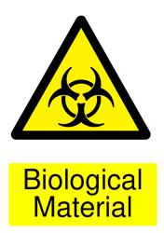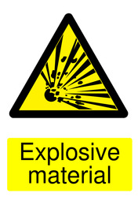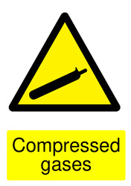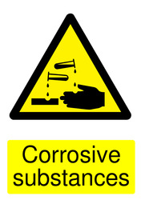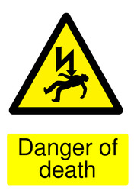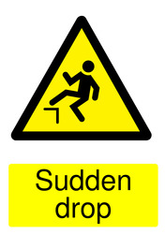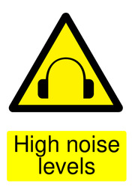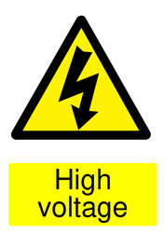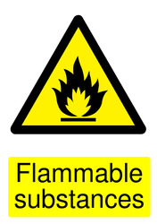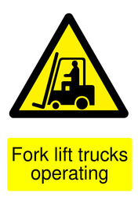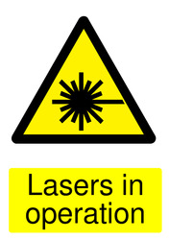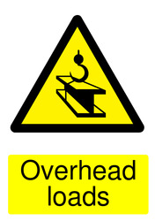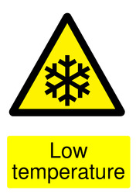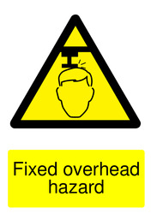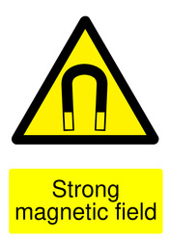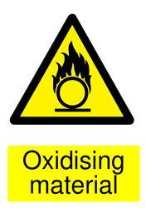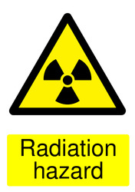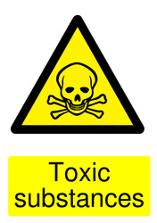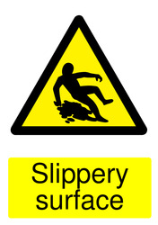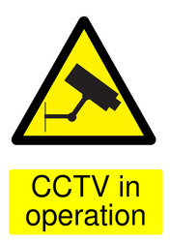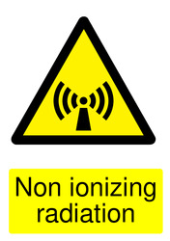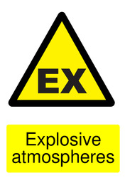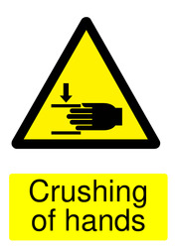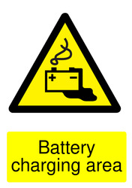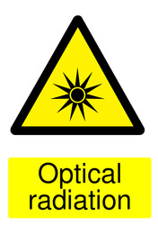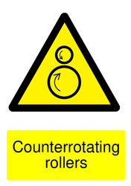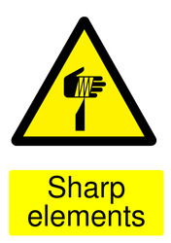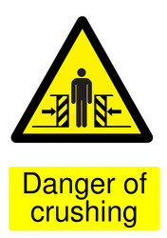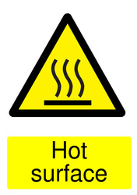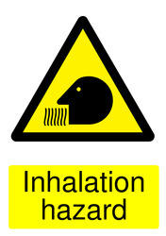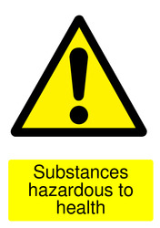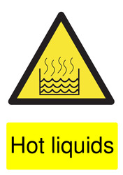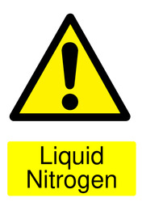

**Prohibition signs**

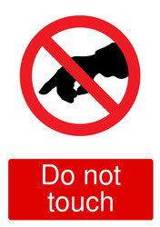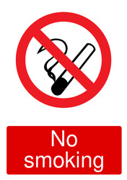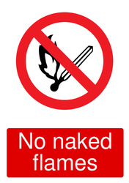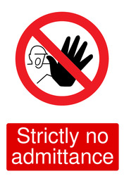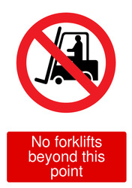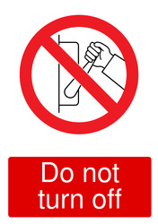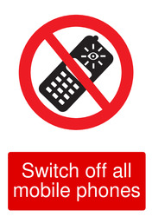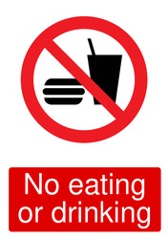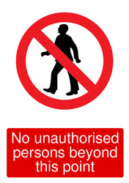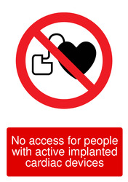

**Mandatory signs**

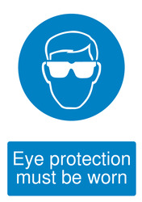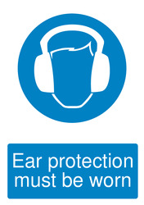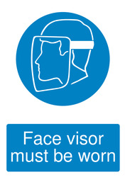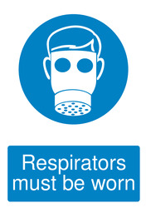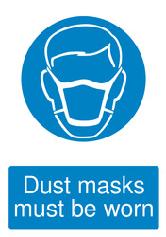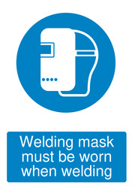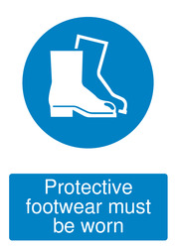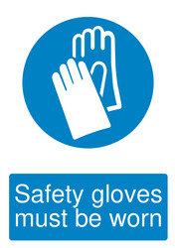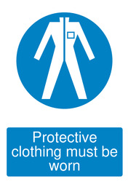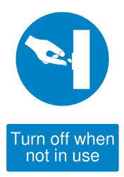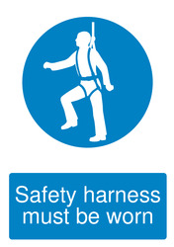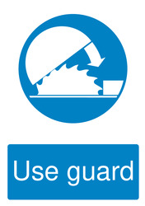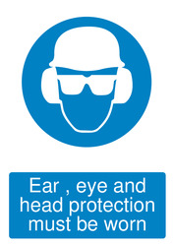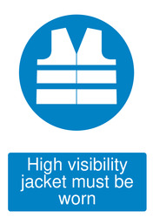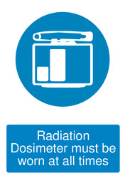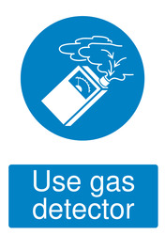

**Activity Dependant Signs**

